**Strength of Materials**

**Prof. S.K.Bhattacharya**

**Dept. of Civil Engineering,**

**I.I.T., Kharagpur**

**Lecture No.26**

**Stresses in Beams-I**

Welcome to the first lesson of the 6th module which is on Stresses in Beams part 1. In the last module we had discussed some aspects of the shear force and bending moment on beams and in this particular module we are going to discuss how to utilize the information on the shear force and bending moment in evaluating the stresses in the beam.

(Refer Slide Time: 01:04-01:05)

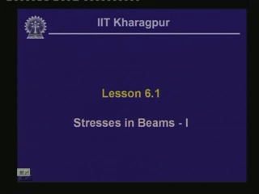

In today’s lesson we will be discussing on the effect of the bending moment on the stresses in a beam. Hence it is expected that once this particular lesson is completed, one should be able to understand the concept of bending stress in a beam and one should be in a position to derive the bending or the flexural equation.

In fact as we have seen in the case of the torsion in a shaft, when we compute the stresses in a shaft or a ball due to twisting moment, we have computed the stresses and there by we had derived the torsion formula. Now on similar lines, when a beam is subjected to a load and is undergoing a bending and shear force as we have seen when we compute the stresses and derive the formula which we call as a bending formula.

(Refer Slide Time: 01:29-02:49)

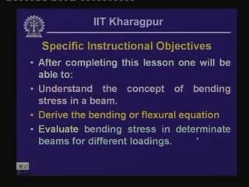

As we go along in this lesson, we will see how to derive the bending equation. Now one should be in a position to evaluate bending stress in determinate beams for different loadings. Here we are qualifying the beam by saying it is a determinate beam as we have seen that the beams which we are dealing with are the reactive forces of this particular beams. We can evaluate the values of the reactive forces based on the equations of equilibrium and hence they are determinate and in this particular course, we are dealing with mainly the determinate systems.

(Refer Slide Time: 02:49-03:18)

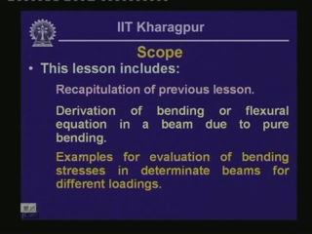

Hence the scope of this particular lesson includes the recapitulation of the previous lesson as we will be discussing the aspects of the previous lessons through the question answer session. We will also be deriving the bending or the flexural equation in a beam due to pure bending. In this particular lesson, we will discuss about the pure bending and then we will looking into some examples for the evaluation of bending stresses in determinate beams for different loadings.

(Refer Slide Time: 03:19-04:06)

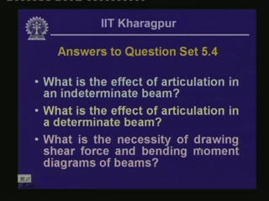

Let us look into the questions which were given last time and their answers. The first question given was on the effect of articulation in an indeterminate beam. Now this is a term wherein we introduce a mechanism in a beam, where at that particular point it can sustain the shear force but it cannot resist any bending moment. What happens if we introduce this kind of articulation in a beam in an indeterminate beam? The next question is that if we introduce a similar kind of articulation in a determinate beam then what will be the consequence?